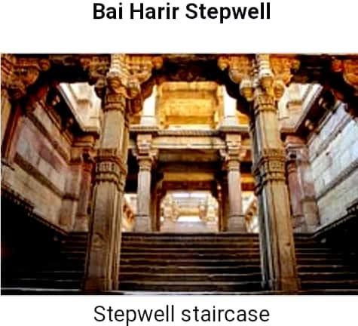

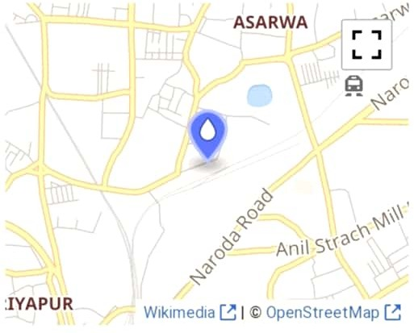

General information

Architectural style Islamic architecture

Town or city Country Coordinates
Alaireclabad

India

23.0402692°N
72 b05416°E

Construction started 1499

Completed

Floor count
15th century

Technical details

Five storied stepwell

Design and construction

Architect

Designations
Local

Monument of National Importance ASI Monument No. N- GJ-18

